Appendix
IE Teaching and Learning Event Lesson Plan and Notes

Day 1
Grabber:
- Blow up balloon and let it go
- Explain this a source of great joy for my two and four year-old

Some students laughed too, and this would be a good hook for getting them talking about silliness, happiness and well-being
Review agenda
Warm-Up Drawing Activity:
- Write the following phrases on the board:
- Well-Being; that which makes life worth living: good life; happiness, health and/or prosperity; satisfaction, pleasant feelings and few unpleasant feelings
- Explain that these are different ways of representing “well-being”
- Hand out bland sheets of paper and coloured pencils/pens
- Ask students to visually represent what comes to mind when they read and think about these phrases

Students enjoyed this process immensely. They chatted as they worked, but were focused on their papers and the tone and energy was positive
I asked if they had the opportunity to do this much, and the answer was, ‘we’re having a colouring competition for a draw’, kind of like what a restaurant might do, but no, very little metaphorical drawing if any in class.

Scales and Questionnaires”
- Distribute the following questionnaires to students:
- Multidimensional students’ life satisfaction scale (MSLSS; Huebner )
- St. Louis Students as Allies Survey (What Kids Can Do)
- Life Satisfaction (Diener www.psych.uiuc.edu/~ediencer/hottopic/hottopic.html
- Ask students to complete the surveys
- Choose an alias and write them on the three surveys plus the drawings
Students were chatting throughout this process. Some questions they seemed to laugh about include: “I I think I am good looking” “I like where I live” “This town is filled with mean people” from the MSLSS – from the St. Louis, the topic of discussion seemed to revolve around the “My school respects all races and cultures” As questions got more personal, they weren’t talking with each other as much.

Small Group Sharing
- Ask students to join up with others and respond to the exercises
- If they are willing, have them share their pictures and discuss thoughts/reactions to the scales. What questions did they raise?
- Have the following questions on the board to guide discussion:
- What is your definition of “well-being”? (originally I planned on using “good life”
- How would you describe someone with well-being?
- How does one have/get well-being?
- Does well-being depend on a) what you’re doing? B) who you are with? C) where you are?
- What about school should stay the same, or would have to change in order to make sure akonga experience well-being from 8-3?
- Ask students to come up with three things form the discussion of #5 to write up on the board

Because I lost 10 minutes at the beginning of class moving rooms, I didn’t have as much time for this last part. Instead, I had students write down responses from the discussion on post it notes. This was not well-done. I should have clarified the questions or have been around the room more, and I should have put them into random groups too, because by now, they were more interested in chatting with each other than focusing on this, with the exception of a few groups

Large Group Sharing
- What are some of the common themes?
- What of these things can be affected/changed/impacted on by you? By your teachers? By the school? By NCEA?
- Put up a transparency of the Record of Learning and ask, of the things you did today, which best represents well-being as you define it?

This didn’t happen

Feedback Experience One
- Ask students to provide feedback on this particular approach to teaching, specifically commenting on the drawing exercise, the self-evaluation via surveys, the small and large group discussions, the mixture of all.
With just a few minutes available, I asked one or two students for oral feedback and had them all do a thumbs up thumbs down rating on the day.

Day 2

Grabber:
- Go over some of the survey results
- Students were all at least slightly satisfied with their lives
- Explain a bit about the research into well-being and why their perspective is relevant and necessary

Round Robin Exercise
- Refer students to the butcher paper hanging up around the room organized as follows:
- Physical; Social; Emotional; Spiritual; Cognitive/Academic
- A. How do you define ____________ well-being
- B. Should senior secondary school be concerned with the promotion of ______ well-being?
- If yes, what recommendations would you make to : Ms Brokenshire, the Board of Trustees, the National Qualifications Authority (NCEA people); and/or the Ministry of Education so that ________ well-being is a focus for senior secondary education?
- Divide students into groups and have each group choose one colour
- Students are to visit each station as a group, read the question and respond.
- After the first shift (5 minutes) students travel clockwise to the next station.
- They are to read what has been written, respond to what has been stated and add to/comment/disagree as appropriate
- After visiting each, they are to end on their first station, read all that has been written, and write one final comment/summary statement/question and circle it.

This has lots of potential, but it would need to have been practiced before, I think. Also, I didn’t have the energy to keep on track of wavering groups, nor did I have the ‘in’ on them to keep on them as I would have in my classes. I don’t think they behaved any differently than they would have had I been the regular teacher, but my ability to focus their attention would have been different. Three groups were on it, two were not. I should have divided them myself, to separate the ‘friends’, but I was thinking on the off chance they would really get into it, being comfortable with their peers would have really added something. I should have known better, though, my gut was to split groups. Mostly because it’s already different that I’m there and that they were doing this. In split groups, I could have played a more active role getting around and checking on their responses. Moreover, Pat wasn’t there. Had she been, I think I would have gotten a bit more focus from them. In terms of different ability levels, I think all ‘got’ this exercise, even the students who tend to have more difficulty focusing in and comprehending directions, though once they get started they are fine. Also, the spirituality one really did get them talking more, and I think there should have been opportunity to get into a debate about character education.

Group Production Work
- Regroup students and explain that their job is to take what we’ve done so far as a warm-up and now that the idea is (hopefully) fresh in their mind about well-being, to take the opportunity to envision what schooling could be like to this end.
- Hand out Cohen et al.’s Indicators of School Climate handout with the following categories (Safety, Teaching and Learning, Institutional Environment, Interpersonal Relationships)
- Each of the five groups is to focus on one aspect (two on t and l, one on t, one on l)
- Explain that they are to present a proposal to an audience of their choice for ways schools could be designed to promote the well-being of students, keeping in mind the five domains we worked on earlier
- Distribute the following hand-out:
SOCIAL EMOTIONAL SPIRITUAL COGNITIVE PHYSICAL WELL-BEING
SAFETY TEACHING LEARNING ENVIRONMENT RELATIONSHIPS
You have in front of you a list describing things considered to be important for the well-being of the school community.
- Your first task is to read the highlighted section on this handout.
- Next, think carefully about and then discuss the ways in which HHS does well in this area.
- Then identify what from your list fits into the following categories:
- Physical
- Social
- Emotional
- Academic/Cognitive
- Spiritual
- Your final task it to bring all this together and create and/or redesign a senior secondary school that promotes the well-being of all students, focusing specifically on your assigned area.
Possible suggestions:
- Draw a picture, diagram or create a song that reflects what this kind of school looks, feels, sounds, smells, (tastes?) like
- Prepare a three minute speech, during which all members must contribute somehow (in words, visuals or gestures), explaining your plan
- Act out a scene from a typical day-in-the-life at this fantastic school of yours
Assessment:
You and your group will be presenting a list of recommendations to an audience of your choice a) the Principal, b) the Board of Trustees, c) the National Qualifications Authority or d) the Ministry of Education (i.e. your peers, your IE teacher, Annie)
The audience will have the opportunity to provide feedback on your performance, and you will be expected to consider and share an assessment of your contributions to this exercise, and your performance.
Thanks for your effort

- Students may use A3 paper, or butcher paper , pens, pencils, etc. to work with
- They are to try to have a rough job done by the end of the day with a few minutes to prepare Thursday before presenting to their audience

Here is especially where students could have been reorganized into different groups. My original thought was to have them continue on with previous, but it may have been beneficial to have them split at this point, if for nothing else, than a change of seen and, better yet, for them to share perspectives. For the two groups that were a bit ‘off’ they weren’t into this at all, as expected. The other three did get into it, I think, and had something to deliver at the end of the day.
I will have to think carefully about the best way for them to present their stuff

Day 3

Introduction:
Overview of survey results

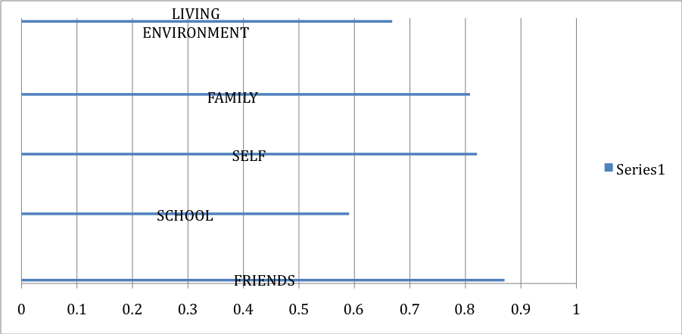

- Ask for students to respond to the figure

I didn’t really format this well, nor did I devote sufficient time/attention to it. They did immediately pick out that friends/school were at the extreme. I asked if this was representative of their experiences here and they agreed. I waxed philosophical a bit at this point before moving on.

Prepare for Presentations

- Ask student to get into groups and go through the packet of handouts which consist of:
  - Tuesday’s A3 paper
  - Participant feedback form
  - Self-evaluation form
  - Evaluation of me
- Ask students to decide on one member who will present, one who will be the Board of Trustees member and one/two who will be observers
- Explain that I decided to break up the groups so that more people would have the opportunity to participate
- Go around to groups individuall and explain that
- presenters are to share their group’s work, basing their presentation on the rubric I handed out for oral presentations
- Board Members will sit across the room from the Presenter and respond to their presenter’s proposal from this different view point, playing devil’s advocate or supporter with rationale
- Observers are to fill out one oral presenation feedback form for presenters and one for the observers in the group. The are to sit on the edges of the table so as to be able to see expressions, body language, etc.

This was all a bit confusing for students, but greatly helpful for me to attend to them one on one. This class in particular does seem to tune out a bit, maybe because of IE?

Presentations
- Each group presents, Board Member Responds, ask for comments from the rest of the BoT

I think this exercise has a lot of potential. I’m pretty sure it’s the first time they had done something like this, so given that, they warmed up pretty quickly. There was the usual laughing/giggling when some of the more assertive students fumbled about and made a bit of a joke about it, although I think they might have equally felt a bit on the spot about it.

If I were to do it again, I would have set it up such that each BoT was to respond in some way to the presenter’s proposal.

As it was, even observers jumped in, and it expanded a bit into more of a discussion, which I thought was great. Had I been teaching the class, I definitely would not have been so active in the discussion, and would have worked on getting them to broaden-and-build on what had been said.

I thought it was interesting that by the end, students really had loosened up a lot and were taking more agency in the discussion. They were not adversarial, not bitter, but they were definitely making some useful comments:
- Bully Busters needing some relooking, as it is, it’s involvement in name – we didn’t really get at, though, if it would be worse for there NOT to be an acknowledgement of bullying via a lack of such an organization,e tc.
- Teachers needing a more active presence during breaks, implying that bullying was going on, and not many people were intervening – this was interesting in that the focus was on remediation, not prevention
- Several inferences to ‘reverse racisim’ and that some students were receiving privileges for things that should just be, like jackets for coming to school, etc.
- More money for books vs. taxes for roads. I used this as an opportunity to consider ‘trade-off’s between education and safety. Trekessa did point out how it all comes around in a circle…
- I didn’t bring up, t hough I wish I had more, family issues.

Evaluations and Chow

- Students were going to go over their own self-evals and the evals of other students in class Friday with Pat
- I handed out my own evaluation for additional feedback from them
- Some of the responses include:
One thing I came to understand better this week: | - About other people’s opinion about the school  - Other peoples opinions of the school, it was interesting
One question that this week has raised for me: | - Why hasn’t the school repaired the school pool?  - Why our school does not have more community spirit
Something I appreciated about this week: | - Chill out with my mates in English  - That we could have an opinion about the school in general
A suggestion I have for Annie with respect to how she can improve the learning experience for me: | - Ask for opinion about other stuff  Ask for opinion about other stuff *Do this more often it would be cool
A suggestion I have for Annie with respect to how she can improve her research project | - Ask for opinion about other stuff  Ask for opinion about other stuff *Do this more often it would be cool

A suggestion for Annie with respect to how she can improve her research project:
- Ask for opinion about other stuff

Other thoughts
* Time – it took time to warm them up to me , given, but also to the thinking that needed to happen to get deeper into this. I think most research gets in and out without building that foundation and observing the ‘click’ when things start to ‘flow’
* Questions – allow them to ask them, just not to get them to answer yours, in this way research is much like good teaching. Facilitating the exploration that is good learning… we can never be completely familiar with the foundational elements that support the steps one takes towards discovery…sociol-cultural, historical, familial, valued circumstances and conditions…they are all influential on their world view. When this world view is neglected, or deemed irrelevant in teaching and in research, we lose the context of the answers.

